**Experiment 4.3**

**Aim:** Write a Python Program to perform file operations.

**Solution:**

import os

reclen=20

with open("cities.bin",'wb') as f:

n=int(input("Number of entries:-"))

for i in range(n):

city=input("Enter city name:")

ln=len(city)

city=city+(reclen-ln)*''

city=city.encode()

f.write(city)

f.close()

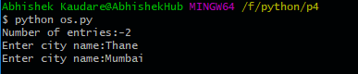

import os

reclen=20

size=os.path.getsize('cities.bin')

print("Size of file={} bytes".format(size))

n=int(size/reclen)

with open("cities.bin",'r+b') as f:

name=input("Enter city name: ")

name=name.encode()

newname=input("Enter new name: ")

ln=len(newname)

newname=newname+(20-n)*''

newname=newname.encode()

position=0

found='false'

for i in range(n):

f.seek(position)

str=f.read(20)

if name in str:

f.seek(-20,1)

f.write(newname)

position+=reclen

if not found:

print("City not found")

f.close()

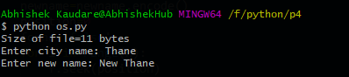

import os

reclen=20

size=os.path.getsize('cities.bin')

n=int(size/reclen)

f1=open('cities.bin','rb')

f2=open('file2.bin','wb')

city=input("Enter city name to delete: ")

ln=len(city)

city=city+(reclen-ln)*''

city=city.encode()

for i in range(n):

str=f1.read(reclen)

if(str!=city):

f2.write(str)

print("Record deleted")

f1.close()

f2.close()

os.remove("cities.bin")

os.rename("file2.bin","cities.bin")

